# System Models

## Use case diagrams

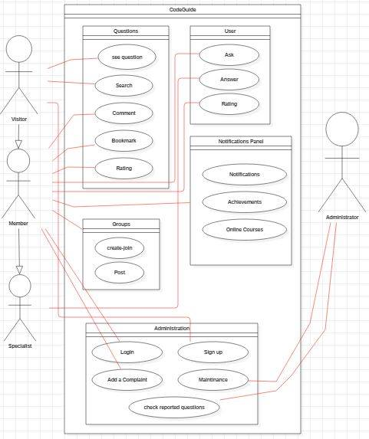

## Sequence diagrams

1. **Specialist**

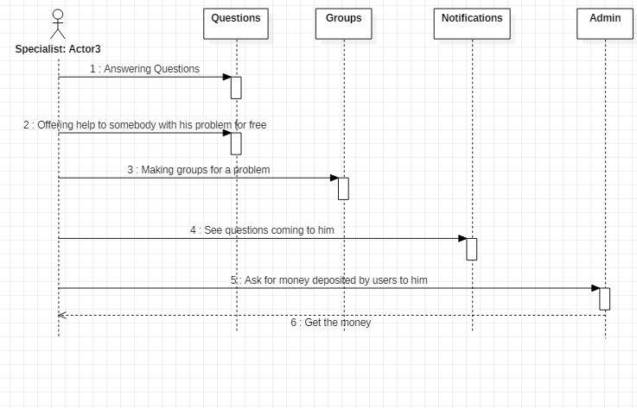

1. **Member**

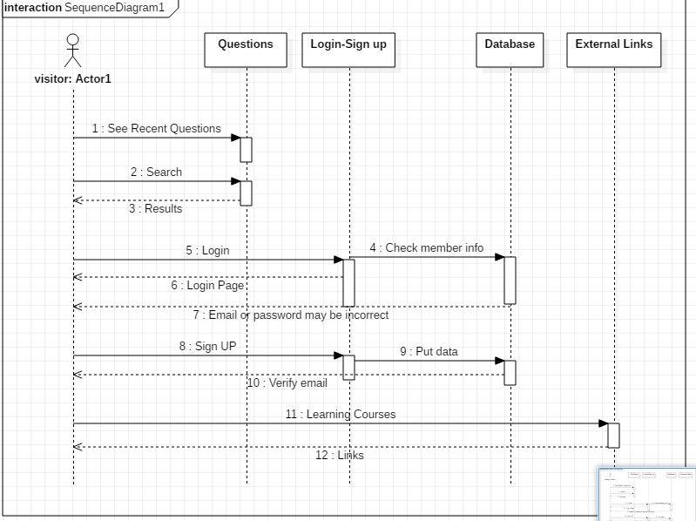

1. **Visitor**

